**Depth Control Using ANFIS Controller**

Safa Bazrafshan

Independent Researcher

Email: safa.bazrafshan@gmail.com

ORCID: https://orcid.org/0009-0004-4029-9550

**Adaptive Neuro-Fuzzy Inference System (ANFIS)**

In this phase, we designed and trained an ANFIS controller for the depth regulation of an Autonomous Underwater Vehicle (AUV). The training data was derived from a previously implemented PID controller. The ANFIS model was trained for 50 epochs with a decreasing RMSE, reaching a minimal training error of 0.0012.

The ANFIS controller consists of:

* 2 inputs (depth error and rate of depth error)
* 1 output (control signal)
* 3 fuzzy rules
* 15 total parameters (6 linear, 9 nonlinear)

**Training Details**

Matlab:

% File: train_anfis_controller.m

% Output: anfis_controller.fis

The training process included adjusting the step size adaptively and refining the fuzzy rules based on input-output training data pairs (301 samples).

**Simulation Result**

The ANFIS controller was applied to the nonlinear AUV model. The depth response is shown below.

Figure_AUV Depth Response Using ANFIS Controller

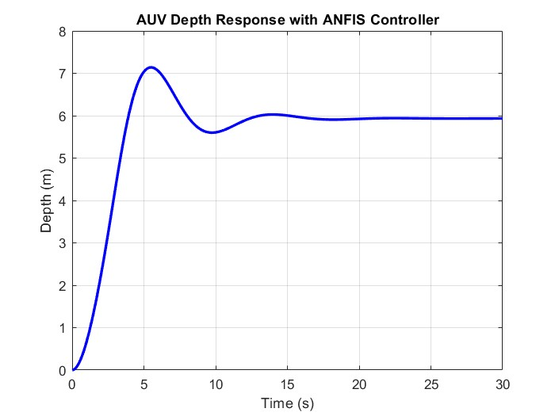

The AUV initially increases its depth from 0 to 7 meters, followed by an undershoot to 5.5 meters.

It then stabilizes around 6 meters from t = 10 seconds onward.

This behavior illustrates the controller’s ability to adapt and suppress oscillations over time.

**Summary**

This phase demonstrates how ANFIS, trained using traditional control data, can generalize and control a nonlinear underwater vehicle system effectively, with fewer oscillations and good final stability.